Service for the Lord’s Day West End Presbyterian Church
October 10, 2021 │ Twenty-sixth Sunday in Ordinary Time

A spectator admires Vincent Van Gogh’s “The Starry Night” in the immersive experience “Beyond Van Gogh”

We Gather as God’s People
Before this morning’s worship service begins, please greet one another in Christian love, taking special care to welcome those who you do not know. May all who enter know that West End Presbyterian Church is a warm and welcoming congregation.

Chiming of the Trinity

Welcome and Announcements

A Moment for Generosity: “Together for Joy”

Prelude “When Morning Gilds the Skies” arr. Jeff Bennett
EVERYONE IS REQUIRED TO WEAR A MASK during worship and all other indoor and outdoor functions at the church.
We will continue to refrain from congregational singing. Please join in reading those parts of the service printed in bold.

When this symbol precedes an element of the service, please rise in body and/or spirit.

Please sign the attendance sheet located in the Narthex.

Children of all ages are invited to join us on the steps during a time for the child in us all.

Before reading from the Bible, we seek the illumination of the Holy Spirit and call upon God to make us receptive to the life-giving Word that comes to us through both the reading and proclamation of Scripture.

Call To Worship Laura Pitts, Liturgist
Praise the Lord!
Let my whole being praise the Lord!
I will praise the Lord with all my life,
I will sing praises to my God as long as I live.
God is the maker of heaven and earth,
The sea, and all that is in them.
God is faithful forever,
And reigns with justice and righteousness.

Invitation to Confession

Prayer of Confession
Gracious and Wondrous God, we confess that we never seem to have enough. We desire to have more. We pursue what we do not have because others have it and we want it. We push ourselves to extremes, ignoring the poor, the oppressed among us, those whose voices we have marginalized, in order to assure ourselves of worldly success, security, wealth, and notoriety. Forgive us for our foolish ways. Lead us in your wisdom to pursue justice and righteousness. Guide us in your way of generosity to a spirit of abundant love and care for those in need among us. Hold us to your truth and help us repent where we have gone astray to the ways of the world, instead of following your way, your truth, and your life, through Jesus Christ, who laid down his life for us. It is in Christ’s name we pray. Amen.

Silent Confession

Assurance of Forgiveness
The Lord is merciful and gracious,
slow to anger and abounding in steadfast love.
As far as the east is from the west,
so far does God remove our sins from us.
Friends, here is good news indeed:
in the name of Christ, we are forgiven.

A Time for the Child in Us All Judy Trivett

We Listen for God’s Word

Prayer for Illumination

The Word Read Hebrews 4:12-16 Page 206, OT, Pew Bible
The Word of God for the People of God.
Thanks be to God.

Special Music “My Jesus, I Love Thee” arr. Lloyd Larson

The Word Read Mark 10:17-31 Page 43, NT, Pew Bible

As you leave worship today, you are invited to place your offering in the offering plates found at the exits.
The Word of God for the People of God.
Thanks be to God.

We Respond to God’s Word

The Word Proclaimed Rev. Donald Stewart
“What Must I Do to Receive Life?”

Affirmation of Faith The Apostles’ Creed
I believe in God the Father Almighty, Maker of heaven and earth, and in Jesus Christ
His only Son our Lord; who was conceived by the Holy Ghost, born of the Virgin Mary, suffered under Pontius Pilate, was crucified, dead, and buried; he descended into hell; the third day he rose again from the dead; he ascended into heaven, and sitteth on the right hand of God the Father Almighty; from thence he shall come to judge the quick and the dead. I believe in the Holy Ghost; the holy catholic church; the communion of saints; the forgiveness of sins; the resurrection of the body; and the life everlasting. Amen.
Prayers of the People & The Lord’s Prayer
Our Father who art in heaven, hallowed be thy name. Thy kingdom come, thy will be done, on earth as it is in heaven. Give us this day our daily bread; and forgive us our debts, as we forgive our debtors; and lead us not into temptation but deliver us from evil. For thine is the kingdom and the power and the glory, forever. Amen.
Offering of Gifts and Tithes

We Follow God’s Word Into the World

Prayer of Dedication
We give our offering hopefully, hoping that you can use these gifts, hoping
that these gifts can further your kingdom, hoping that your kingdom will
come. Your kingdom, your will be done, on earth as it is in heaven. Amen.

Doxology

Charge and Benediction

WPostlude “Postlude in B flat” by Caleb Semper, arr. Michael Ryan

W

Today’s flowers are given to the glory of God
in memory of Linda Lee Thomas
by Jennifer Thomas & Marilyn Thomas

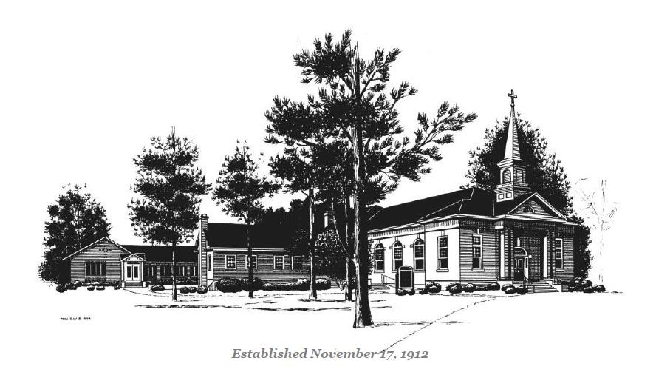

West End Presbyterian Church
www.westendpres.church
PO Box 13  275 Knox Lane W West End, NC 27376

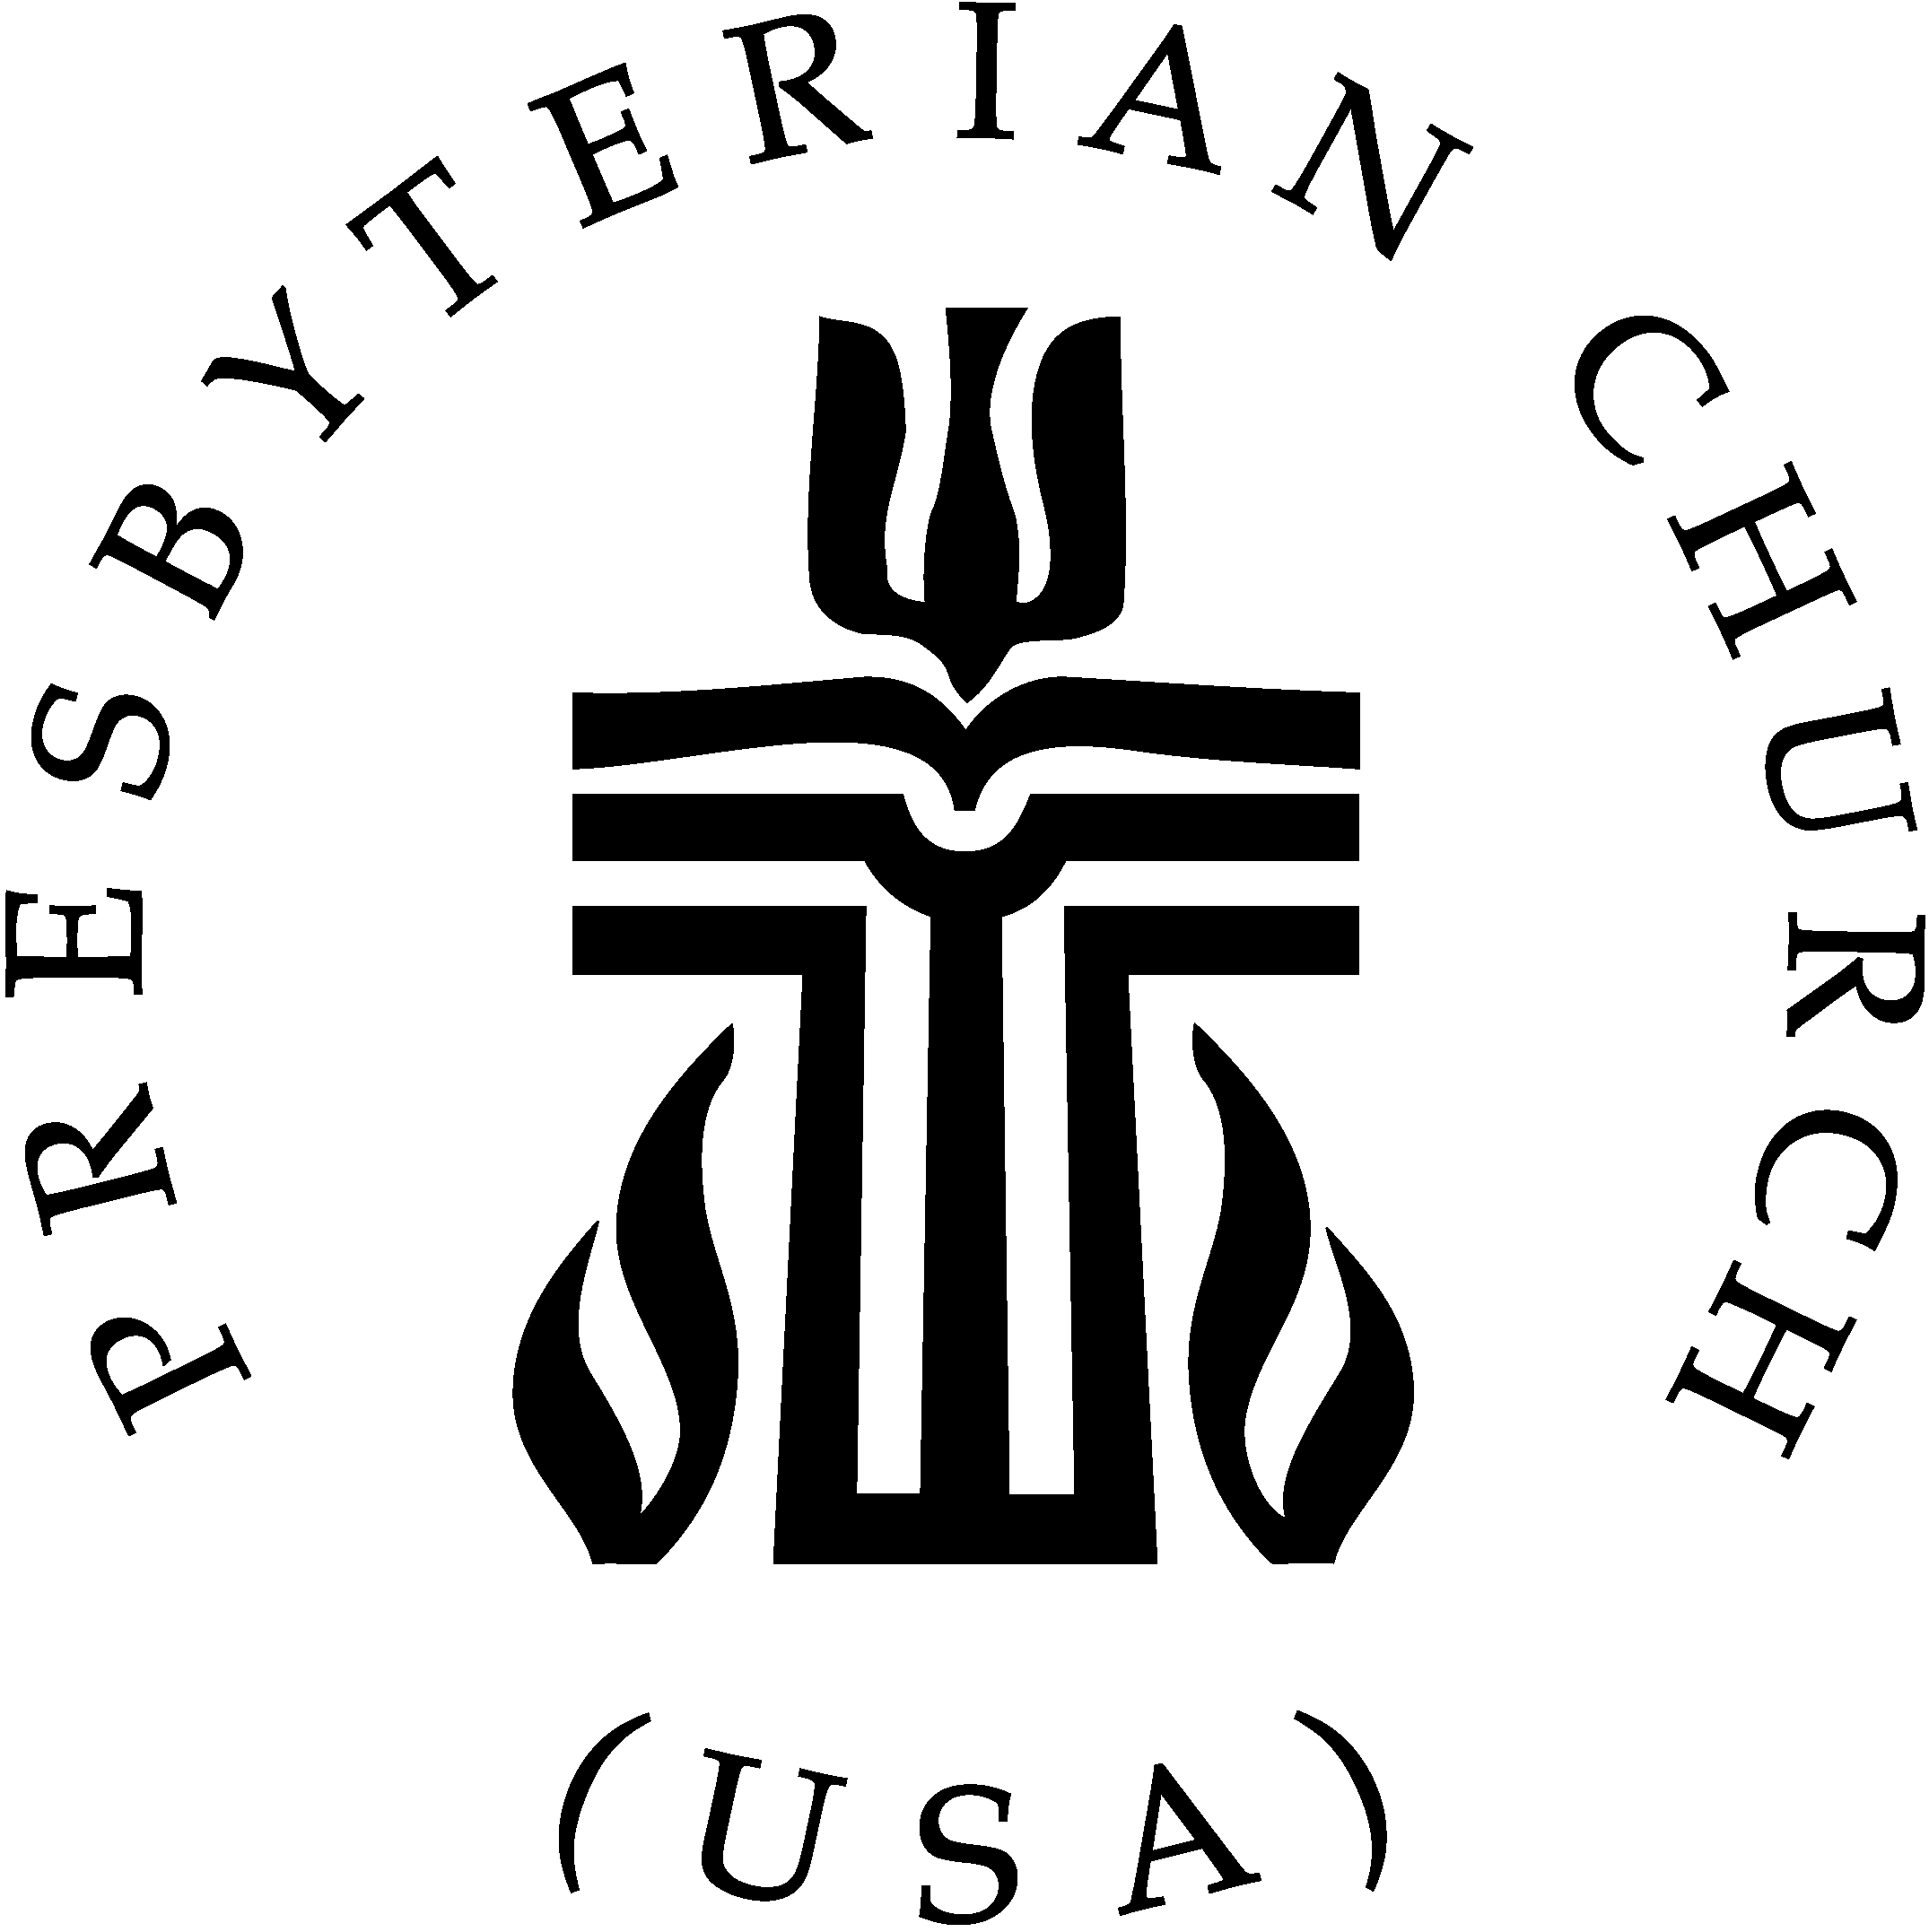
Jennifer Thomas, Director of Music jennifer@westendpres.church
& Interim Church Administrator churchadmin@westendpres.church
Paula Montgomery, Finance Administrator paula@westendpres.church
Kathy Hess, Sexton

